Epsom & Ewell F.C.
19
v
Westfield
Saturday, 14th April 2018 – 3.00 p.m.
Good afternoon and welcome to High Road for our League match against Westfield. We welcome their players, supporters and officials and wish them a safe journey home, as of course we do for our own regular supporters.

Westfield visited High Road around 14 months ago, winning 2-1, but since then it’s fair to say that our paths have gone in different directions. Our story is well known this season, while obviously Westfield defeated us in last season’s League Cup Final at Windsor FC and this season has been an almost total success in the League, although I’m sure they’ll look back at this season and wonder why they didn’t progress further in the Cups. However, we congratulate them on their League title, that they probably achieved on Thursday evening and hope that they will ease off the gas a little today as a result!

We were last here on Thursday 5th April when we hosted Banstead Athletic and were unable to hold on after building a 2-0 half time lead. Reisse Griffin scored a stunning volley which was added to by a Kyen Nicholas header but we had to settle for a 2-2 draw. Following that we had a quick turnaround for a visit to the Spectrum on Saturday with Guildford City and we were narrowly defeated 4-3 after it was our turn to recover a first half two goal deficit, only to run out of steam in the end.

This followed our 0-1 Good Friday defeat at home to Colliers Wood United and it is worth noting that we have yet to score in a Good Friday match since we first trialled this experiment against today’s visitors, which I think I am right in saying was the first match in charge for their Manager Tony Reid back in 2016.

Following today’s encounter we have a busy week. We host CB Hounslow United on Tuesday in a match moved back twice previously and then visit North Greenford United on Thursday evening. Thankfully we then have the Saturday off before finishing our campaign with a trip to Walton & Hersham at the new Elmbridge Sports Hub on Tuesday 24th April and return here four days later for our final match of the season at home to AFC Hayes.

Our Centenary dinner has almost been confirmed with a provisional date and venue of Saturday 8th September at the Epsom Golf Club. Further details will follow as soon as we have them. We should also have our Centenary kit on show shortly too. We also have our Player of the Year forms out so please get voting!

Enjoy the game!

Rich

Don’t forget, you can now follow us on Social Media. Please see the inside cover for addresses.

Cover photos by Gemma Jarman

1) Kyen Nicholas scores our second goal against Banstead Athletic on 5th April
2) Kyen Nicholas scores our second goal at Guildford City on 7th April
1
Cherry Red Records Combined Counties League
Premier Division Table 2017/18
inc Tuesday 10th April | P | W | D | L | F | A | Pts | GD | H | A
Westfield | 35 | 32 | 1 | 2 | 131 | 33 | 97 | +98 | 14/4 | 0-5
Bedfont Sports | 37 | 26 | 5 | 6 | 93 | 53 | 83 | +40 | 2-4 | 0-7
Sutton Common Rovers | 37 | 25 | 4 | 8 | 83 | 41 | 79 | +42 | 0-2 | 0-5
Walton & Hersham | 37 | 22 | 6 | 9 | 75 | 47 | 72 | +28 | 0-2 | 24/4
Camberley Town | 38 | 13 | 20 | 5 | 50 | 36 | 59 | +14 | 0-0 | 1-1
Redhill | 36 | 16 | 5 | 15 | 70 | 59 | 53 | +11 | 0-5 | 0-3
Spelthorne Sports | 39 | 15 | 8 | 16 | 64 | 60 | 53 | +4 | 1-5 | 0-0
CB Hounslow United | 33 | 15 | 5 | 13 | 61 | 47 | 50 | +14 | 17/4 | 2-4
Balham | 30 | 15 | 5 | 10 | 61 | 49 | 50 | +12 | 0-2 | 0-4
Knaphill | 34 | 13 | 11 | 10 | 62 | 54 | 50 | +8 | 0-0 | 2-6
Horley Town | 36 | 14 | 7 | 15 | 53 | 70 | 49 | -17 | 2-3 | 2-3
Guildford City | 37 | 13 | 7 | 17 | 63 | 79 | 46 | -16 | 1-3 | 3-4
Abbey Rangers | 35 | 11 | 10 | 14 | 52 | 53 | 43 | -1 | 1-1 | 0-0
Hanworth Villa | 35 | 11 | 9 | 15 | 56 | 73 | 42 | -17 | 1-1 | 3-2
North Greenford United | 30 | 11 | 8 | 11 | 52 | 52 | 41 | 0 | 1-2 | 19/4
Colliers Wood United | 35 | 12 | 4 | 19 | 58 | 63 | 40 | -5 | 0-1 | 2-5
AFC Hayes | 32 | 10 | 6 | 16 | 45 | 63 | 36 | -18 | 28/4 | 0-2
Chertsey Town | 36 | 10 | 6 | 20 | 56 | 78 | 36 | -22 | 2-7 | 0-1
Banstead Athletic | 35 | 8 | 7 | 20 | 44 | 84 | 31 | -40 | 2-2 | 1-1
Godalming Town | 35 | 8 | 6 | 21 | 43 | 75 | 30 | -32 | 0-3 | 2-1
Farnham Town | 37 | 5 | 10 | 22 | 44 | 84 | 25 | -40 | 3-0 | 0-0
Epsom and Ewell | 37 | 3 | 10 | 24 | 34 | 97 | 19 | -63 | X | X

Lucky Day? – 14th April
Played 17 - Won 10 Drawn 1 Lost 6 - For 34 Against 19 - PPG 1.82 - Good
Our Club record against Westfield
Played 22 - Won 12 Drawn 3 Lost 7 - For 43 Against 41 - PPG 1.77 - Good
Largest wins and losses against Westfield
21st October 1967 - W 6-1 - Amateur Cup Second Qualifying Round (H)
9th December 2017 - L 0-5 - Combined Counties League (A)
Westfield’s Last Visit
Saturday 12th February 2017 - Won 2-1 - Combined Counties League

First Eleven Appearances 2017/18 - (max 43)
Name | Debut | 2017/18 |  |  |  | Career Totals
 |  | App | Sub | Tot | Goals | App | Sub | Tot | Goals
AJAYI Tayo* | 06/08/2017 | 3 | 4 | 7 | 1 | 3 | 4 | 7 | 1
ANDERSON Miguel | 03/02/2018 | 4 | 2 | 6 | 0 | 4 | 2 | 6 | 0
BROOKS Jordan* | 06/08/2017 | 3 | 0 | 3 | 0 | 3 | 0 | 3 | 0
BURROWES Joshua* | 02/12/2017 | 1 | 1 | 2 | 0 | 1 | 1 | 2 | 0
CASTELL Cristian* | 06/08/2017 | 2 | 4 | 6 | 0 | 2 | 4 | 6 | 0
CAULCRICK Joshua | 17/02/2018 | 0 | 1 | 1 | 0 | 0 | 1 | 1 | 0
CLARK Jordan | 17/02/2018 | 0 | 2 | 2 | 0 | 0 | 2 | 2 | 0
CONNELLY Lloyd | 14/10/2017 | 25 | 4 | 29 | 2 | 25 | 4 | 29 | 2
DEWAR Ali* | 29/10/2011 | 1 | 2 | 3 | 0 | 56 | 42 | 98 | 10
DOBRAJ Endrit | 18/11/2017 | 16 | 3 | 19 | 0 | 16 | 3 | 19 | 0
DYSON Ben | 12/08/2017 | 26 | 10 | 36 | 2 | 26 | 10 | 36 | 2
FRANKLIN Ben | 03/03/2015 | 3 | 1 | 4 | 0 | 4 | 1 | 5 | 0
GRAHAM Bentley* | 09/02/2016 | 3 | 0 | 3 | 0 | 20 | 1 | 21 | 3
GRANDISON Kane* | 11/11/2017 | 7 | 1 | 8 | 0 | 7 | 1 | 8 | 0
GRIFFIN Reisse | 08/08/2015 | 26 | 0 | 26 | 2 | 99 | 13 | 112 | 8
HARLAND-GODDARD Tom* | 06/08/2017 | 1 | 1 | 2 | 0 | 1 | 1 | 2 | 0
HARRIS Colin* | 04/08/2012 | 9 | 0 | 9 | 0 | 34 | 0 | 34 | 0
HATFIELD Jamie* | 11/11/2006 | 9 | 1 | 10 | 0 | 258 | 14 | 272 | 6
HAYWARD Ben* | 07/03/2007 | 5 | 1 | 6 | 0 | 248 | 29 | 277 | 18
HEAGNEY Adam | 16/08/2016 | 26 | 3 | 29 | 0 | 63 | 12 | 75 | 1
HENDRY Rob* | 08/08/2015 | 16 | 1 | 17 | 5 | 84 | 23 | 107 | 28
HOUGH Kyle* | 14/08/2007 | 10 | 2 | 12 | 6 | 343 | 21 | 364 | 207
JASPER Joe* | 11/11/2017 | 0 | 1 | 1 | 0 | 0 | 1 | 1 | 0
JEANNOEL Germaine | 02/12/2017 | 2 | 6 | 8 | 1 | 2 | 6 | 8 | 1
KENNEDY Calum | 18/11/2017 | 2 | 1 | 3 | 0 | 2 | 1 | 3 | 0
LAW Franky* | 06/08/2017 | 3 | 0 | 3 | 0 | 3 | 0 | 3 | 0
LOFTUS-CHEEK Joe | 06/08/2017 | 10 | 7 | 17 | 2 | 10 | 7 | 17 | 2
MACAULEY Alvin | 10/03/2018 | 0 | 2 | 2 | 0 | 0 | 2 | 2 | 0
MARKS Samuel* | 06/01/2018 | 1 | 2 | 3 | 0 | 1 | 2 | 3 | 0
MARVELL Dale* | 15/01/2000 | 17 | 2 | 19 | 0 | 286 | 51 | 337 | 86
MASTERSON Shaun | 25/11/2017 | 7 | 3 | 10 | 0 | 7 | 3 | 10 | 0
MCKAY Alex | 20/12/2008 | 28 | 1 | 29 | 1 | 159 | 38 | 197 | 13
MULLINGS Corey* | 23/12/2017 | 0 | 2 | 2 | 0 | 0 | 2 | 2 | 0
MURPHY George | 19/03/2013 | 2 | 0 | 2 | 0 | 70 | 7 | 77 | 3
MURPHY Scott | 20/01/2007 | 30 | 0 | 30 | 2 | 42 | 2 | 44 | 3
MYERS Antony* | 23/12/2006 | 1 | 0 | 1 | 0 | 76 | 33 | 109 | 9
NICHOLAS Kyen | 13/01/2018 | 10 | 2 | 12 | 6 | 10 | 2 | 12 | 6
NWACHUKWU Jason* | 01/10/2016 | 9 | 4 | 13 | 2 | 26 | 20 | 46 | 3
O'BRIEN Louis | 28/08/2017 | 2 | 6 | 8 | 0 | 2 | 6 | 8 | 0
PINDER Marlon | 13/01/2018 | 9 | 1 | 10 | 1 | 9 | 1 | 10 | 1
ROBERTS Liam | 12/08/2017 | 21 | 10 | 31 | 5 | 21 | 10 | 31 | 5
ROBINSON Sam* | 22/10/2011 | 5 | 0 | 5 | 0 | 66 | 6 | 72 | 14
ROSE Daniel* | 25/10/2016 | 14 | 2 | 16 | 1 | 16 | 7 | 23 | 1
RUSSELL Stuart | 30/03/2018 | 1 | 1 | 2 | 0 | 1 | 1 | 2 | 0
SAMPAT Mohammed* | 23/12/2017 | 3 | 0 | 3 | 0 | 3 | 0 | 3 | 0
SELLICK Rory | 27/01/2018 | 6 | 0 | 6 | 1 | 6 | 0 | 6 | 1
SMITH Andy* | 25/08/2017 | 2 | 0 | 2 | 0 | 2 | 0 | 2 | 0
SMITH Taryn | 28/10/2017 | 7 | 3 | 10 | 0 | 7 | 3 | 10 | 0
STEW-LEWIS Noah | 09/12/2017 | 6 | 2 | 8 | 0 | 6 | 2 | 8 | 0
THOMPSON Ashley | 21/08/2017 | 31 | 1 | 32 | 4 | 31 | 1 | 32 | 4
THOMPSON Elliott | 09/02/2016 | 3 | 0 | 3 | 0 | 10 | 9 | 19 | 1
THOMSON David* | 02/09/2017 | 2 | 2 | 4 | 0 | 2 | 2 | 4 | 0
TURPIE Ali | 31/03/2016 | 1 | 0 | 1 | 0 | 12 | 1 | 13 | 0
WHITE Sean | 02/08/2014 | 14 | 7 | 21 | 2 | 20 | 20 | 40 | 5
YOUNG Conor | 07/03/2015 | 28 | 0 | 28 | 0 | 29 | 0 | 29 | 0
* Player has left the club

Recent Results and Fixtures
Combined Counties League – Thursday 24th March 2018
North Greenford United | 1-1 | Camberley Town
Combined Counties League Cup SF – Saturday 24th March 2018
Worcester Park | 3-2 | Sutton Common Rovers
Combined Counties League – Saturday 24th March 2018
Abbey Rangers | 2-1 | Horley Town
AFC Hayes | 3-2 | Guildford City
CB Hounslow United | 5-1 | Chertsey Town
Colliers Wood United | 0-1 | North Greenford United
Epsom & Ewell | 2-4 | Bedfont Sports
Farnham Town | 1-1 | Knaphill
Godalming Town | 2-4 | Spelthorne Sports
Hanworth Villa | 0-3 | Redhill
Westfield | 7-1 | Banstead Athletic
Combined Counties League – Tuesday 27th March 2018
Camberley Town | 0-1 | Sutton Common Rovers
Farnham Town | 0-4 | Redhill
Westfield | 4-0 | Walton & Hersham
Combined Counties League – Friday 30th March 2018
Epsom & Ewell | 0-1 | Colliers Wood United
Combined Counties League – Saturday 31st March 2018
Horley Town | 0-1 | Guildford City
Spelthorne Sports | 2-2 | Farnham Town
Sutton Common Rovers | 1-1 | Redhill
Combined Counties League – Monday 2nd April 2018
Chertsey Town | 1-1 | Abbey Rangers
Epsom & Ewell | p-p | Banstead Athletic
Combined Counties League – Tuesday 3rd April 2018
Walton & Hersham | 2-0 | Spelthorne Sports
Combined Counties League – Wednesday 4th April 2018
Colliers Wood United | 2-1 | Hanworth Villa
Combined Counties League – Thursday 5th April 2018
Epsom & Ewell | 2-2 | Banstead Athletic
Farnham Town | 0-3 | Camberley Town
North Greenford United | 1-2 | Westfield
Combined Counties League – Saturday 7th April 2018
AFC Hayes | 1-0 | Farnham Town
Balham | 2-1 | Abbey Rangers
Banstead Athletic | 1-3 | Spelthorne Sports
Camberley Town | 2-0 | Hanworth Villa
Recent Results and Fixtures
Combined Counties League – Saturday 7th April 2018
CB Hounslow United | 1-1 | Knaphill
Chertsey Town | 1-0 | Godalming Town
Guildford City | 4-3 | Epsom & Ewell
Redhill | 7-2 | North Greenford United
Sutton Common Rovers | 0-1 | Bedfont Sports
Westfield | 3-1 | Colliers Wood United
Combined Counties League – Tuesday 10th April 2018
Balham | p-p | CB Hounslow United
Banstead Athletic | p-p | Sutton Common Rovers
North Greenford United | p-p | Godalming Town
Redhill | p-p | AFC Hayes
Walton & Hersham | 3-0 | Horley Town
Westfield | p-p | Chertsey Town
Combined Counties League – Wednesday 11th April 2018
Colliers Wood United | V | Abbey Rangers
Combined Counties League – Thursday 12th April 2018
Balham | V | Farnham Town
Banstead Athletic | V | Balham
Westfield | V | Knaphill
Combined Counties League – Friday 13th April 2018
Colliers Wood United | V | Walton & Hersham
Combined Counties League – Saturday 14th April 2018
Abbey Rangers | V | Redhill
Bedfont Sports | V | Banstead Athletic
Camberley Town | V | AFC Hayes
Epsom & Ewell | V | Westfield
Farnham Town | V | Guildford City
Godalming Town | V | Sutton Common Rovers
Horley Town | V | CB Hounslow United
Knaphill | V | Chertsey Town
North Greenford United | V | Balham
Spelthorne Sports | V | Hanworth Villa
Combined Counties League – Tuesday 17th April 2018
AFC Hayes | V | Chertsey Town
Banstead Athletic | V | Redhill
Epsom & Ewell | V | CB Hounslow United
Hanworth Villa | V | Godalming Town
Knaphill | V | Guildford City
North Greenford United | V | Abbey Rangers
Westfield | V | Balham

From behind the goal
Epsom & Ewell 0-1 Colliers Wood United
Combined Counties League - Premier Division - Friday 30th March 2018

Salts in real danger now, following another defeat

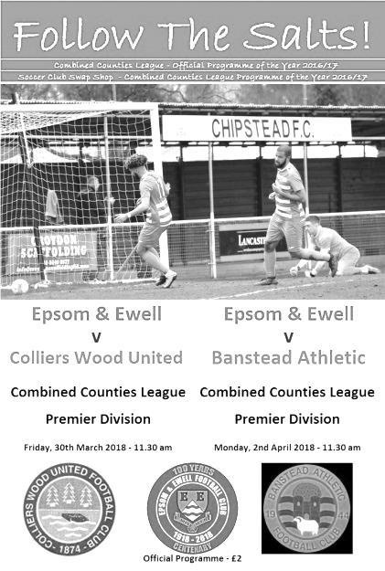
As all Epsom and Ewell supporters know, the spectre of relegation has been hanging over us since the shocking start to our Centenary season, but any slim chance of survival has now probably gone following our home defeat to Colliers Wood United; their fourth in a row over us, all of which have come on a Friday.

Although the contest was an even one in the first half, the visitors completely controlled the second period and had they won by more than a 55th minute Reanu Grossett goal then we couldn't have complained. However, we failed to take two golden chances just before half time and had we done so, maybe the result would have gone our way and our outlook would have been a lot brighter.

In our line-up Adam Heagney returned to the starting eleven and alongside making his debut was Stuart Russell who had played for our Reserves a few years back when we won the Surrey Elite League. Up front Elliott Thompson was away and so Louis O'Brien came in for his first start for a few months after a couple of promising displays from the bench in recent matches.

We were maybe fortunate that the match was on. The High Road pitch is a total sponge but our landlords had seen their match for the previous evening called off, so there was concern. However, a dry overnight spell gave it time to recover and it played well throughout, even though we had further torrents during the match which will surely cause many of the weekend games in our area to be called off.

The first half was very even. We had an early chance in the 8th minute when O'Brien skipped past a challenge on the left, but his pull back lacked accuracy and was cleared by a defender. In reply Conor Young fielded a long range effort that took a bit of a hop in front of him. We looked quite dangerous when pushing forwards, although the visitors had more shots on goal and one such opportunity came in the 25th minute when the ball came in from the left and was fed across to Reanu Grossett but the build-up took too long and we made a defensive challenge in the nick of time to deflect the

shot for a corner.

Liam Roberts, again playing in an unfamiliar role up front made some space on the right wing and fed Ben Dyson with a clever inside pass but Dyson's shot on goal from a narrow angle was well blocked by Sean Fallon. At the other end in the 36th minute Theo Woodhouse rode two weak challenges and drilled his shot against Young's left hand post and away to safety.

As the game approached half time the play became a bit stretched and switched frantically from end to end. We then broke down the right wing where Dyson put over a superb cross to O'Brien unmarked at the far post but the ball hit him on the shin and flew back across goal from just six yards out with the goal gaping! Minutes later we had another opportunity when Roberts pressured Fallon who slipped as he kicked the ball away. It fell straight to Scott Murphy, and to be fair he got his shot away at goal very quickly, but from over 30 yards it was about a yard high and wide of the target.

With the chances we had created there was plenty to be positive about going into the second half. Regrettably though we never really got going. Colliers Wood found a way to get through our defence on regular occasions during the second half and although we had the first chance of the half when Russell's shot took a heavy deflection on its way through to Fallon, it was the visitors who went ahead in the 55th minute. Russell was well positioned but was outnumbered and Reanu Grossett cut inside him and drilled the ball low and inside Young's left hand post for what would prove to be the only goal of the match.

The visitors grew in confidence from that point while we seemed to struggle to string anything together in the pouring rain. Young was out to save quickly just two minutes after the goal and made further saves in the 64th and 72nd minute. We had one decent chance in the second half when Lloyd Connelly's header at goal was deflected for a corner, and from Adam Heagney's corner the ball wasn't cleared and it pinged around in the Wood six yard area before being cleared. Another Young save in injury time was the final action of a disappointing half.

It has to be said that we have played better than we did today, in fact just six days previously against Bedfont Sports. However, despite this, on another occasion we might have been two goals up at the half and with something to defend we might have got away with a result. That would have been harsh on the visitors though who played the way they usually play, with pace and threat down the flanks, and we were just unable to deal with it over the ninety minutes.

Epsom and Ewell: Conor Young, Endrit Dobraj, Stuart Russell, Adam Heagney, Alex McKay (c), Ashley Thompson, Ben Dyson, Scott Murphy, Liam Roberts, Louis O'Brien, Lloyd Connelly

Subs: Marlon Pinder for Dyson (59), Germaine Jeannoel for Roberts (70), Alvin MacAuley for O'Brien (85)

From behind the goal
Epsom & Ewell 2-2 Banstead Athletic
Combined Counties League - Premier Division - Thursday 5th April 2018

Banstead comeback frustrates Salts

A half time two goal lead proved insufficient as a determined fightback from the visitors enabled them to take a point from a lively but ultimately frustrating encounter at High Road.

We named quite a strong team for this match with the return of Marlon Pinder and Kyen Nicholas up front, while Reisse Griffin and Elliott Thompson were back in the line-up after also missing the Colliers Wood defeat. Griffin was back in his original role for the club on the right wing though as Shaun Masterson returned in place of Stuart Russell at left back. Ashley Thompson and Liam Roberts were missing while Louis O'Brien and Lloyd Connelly dropped to the bench.

The match started fairly evenly. We had a shot charged down, while Nicholas was fouled on the edge of the area but play was rather concerningly waved on by the referee. The visitors had the first shot of the match sending the ball over from close range as early as the third minute and two more efforts were headed away by Griffin and caught by Conor Young as we began to see a little less of the ball.

However, the pattern of the match changed in the 22nd minute when a good ball down the left found Ben Dyson in space and he sent over a great cross that Nicholas reached first. I thought the header was going in as visiting custodian Jack Minchin was going the other way, but he somehow turned and made the save. However, his reward was precisely nothing as the ball wasn't fully cleared and as it fell to ground, Griffin struck a sumptuous low volley just inside the keeper's left hand post from about fifteen yards from an angle. It was a superb strike and completely caught everyone out, including the supporters who maybe couldn't believe what they'd just witnessed!

The goal gave us a bit of confidence and we started to threaten a bit more as the half progressed. Nicholas was just wide of the far post with a curling effort after

some good interplay between himself and Griffin and soon afterwards he threatened at the back post but the ball got away from our big centre-forward and Minchin was able to kick the ball away under pressure.

In response the visitors appeared to be running out of ideas a little and it was maybe no surprise when we extended our lead. Dyson again turned provider with a deep left wing cross that Scott Murphy chased and retrieved. He then sent a perfect cross that dropped just over Minchin and to the far post where Nicholas headed the ball into the net from a couple of yards out.

The opening minutes of the second half were key. Only twice before this season had we held a two-goal lead and in both matches, at Rusthall and at home to Farnham Town, we had extended the lead within a few minutes of the second period and gone on to win comfortably. If we could just do it again here, it might well be enough to see off our opponents. Instead though we conceded from a 48th minute corner that appeared to go in off the side of Liam Holden's face. Still, they all count and we were now in a battle. Two substitutions were made as Russell came on for the injured Masterson, while Thompson limped off to be replaced by Connelly. However, this meant that Griffin found himself playing deeper than he had been and we provided less of an attacking threat as a result.

And in the 63rd minute they were level after their left winger got around Endrit Dobraj and pulled it back to Billy Frost who was in far too much space and sent his shot into the far corner of the net from about twelve yards out, giving Young no chance. It had been coming though as they stretched us on either flank in much the same way as Colliers Wood had done six days previously.

We tried to regain the lead. Adam Heagney sent in a teaser of a free kick that we just didn't gamble on, while Ben Dyson cleared the bar by inches with a well struck twenty yarder and then in the 83rd minute Nicholas got away on the right, cut in and shot at goal. Minchin half saved the shot with the ball going across goal where Pinder was able to hook it in from the edge of the six yard area. It was therefore somewhat of a surprise to see the offside flag raised against him. It looked harsh at first glance but the goal was chalked off and the whistle went a few minutes later with the result no one wanted.

On many occasions this season we have competed well against our opponents, only to find ourselves behind anyway. This time we finally got the breaks but couldn't hold on and in all fairness a point each was a fair result. It's just so much harder to take when you've been 2-0 up!

Epsom and Ewell: Conor Young, Endrit Dobraj, Shaun Masterson, Adam Heagney,
Alex McKay (c), Elliott Thompson, Reisse Griffin, Scott Murphy, Kyen Nicholas,
Marlon Pinder, Ben Dyson

Subs: Stuart Russell for Masterson (50), Lloyd Connelly for Thompson (57),
Joe Loftus-Cheek for Dyson (83)

From behind the goal
Guildford City 4-3 Epsom & Ewell
Combined Counties League - Premier Division - Saturday 7th April 2018

Points slip away at the Spectrum

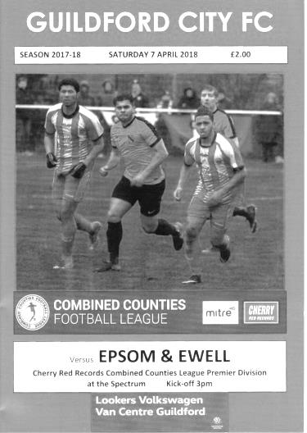
An opportunity missed is the best description of Saturday's match against Guildford City at the Spectrum, although it was a personal success for Kyen Nicholas who produced his best performance in an Epsom shirt and worried the life out of the Guildford defence for much of the match.

In our line-up Adam Heagney and Reisse Griffin were unavailable so Lloyd Connelly found himself in the unusual position of centre-half alongside Alex McKay, and after an opening ten minutes while he found his feet, he did well throughout the remainder of the match. Also coming back into the line-up was Ashley Thompson who slotted into his usual position in the middle of the park.

It was apparent straight from kick off as the ball hopped and bounced randomly on an appalling surface, that playing football on the deck was going to be largely a futile exercise and whichever team adapted better to the conditions would probably win the match. The Guildford match programme had referred to the upcoming removal of the athletics track for a better surface and it is to be hoped that the Council do not stop there as this surface was borderline dangerous and makes a mockery of some earlier postponements this season because some areas of a pitch might have been "a little soft". This was a proper ankle turner!

Unfortunately we went behind in the 3rd minute when a corner delivered towards the near post area was clipped into the far corner of the net by the home Captain Luke Beale from about twelve yards. It was a neat volley which on another day might have been blocked by one of our defenders, but the shot went just between the pair we had near the line.

The home team, fresh from recording their first win in nine matches a few days previously, grew in confidence after their start and in fairness could have extended their lead with McKay blocking a goalbound shot and another fired over from fairly close range. On the quarter of an hour mark Conor Young tipped another effort over the bar and it was beginning to look like it was a matter of time before we conceded again.

However, Nicholas then received the ball just over the half way line and ran at the opposition, beating three men but just hooking his shot across the goal from about twelve yards with just the keeper to beat. It would have been a really special goal, but it also gave our boys a little more belief that if they could pressure the home side they were vulnerable at the back too, and a few minutes later Ben Dyson won the ball well and set up Elliott Thompson who found Nicholas on the edge of the box whose low drive missed Kornel Ziobrowski's left hand post by about a foot. Dyson himself was just wide with a curling effort on the half hour mark and it is a credit to our young player that he works so hard each week, despite having played in almost every outfield position at some point during this season.

As we approached half time we were in the ascendency and Nicholas tangled in the area with a

defender, leading to both of them hitting the deck, but the referee quite clearly decided that there was not enough there for a decision either way, and just allowed the play to continue. Unfortunately we then conceded possession from a throw in in our own half with a subsequent pass to Robbie Mundow who ran at goal the same way that Nicholas had done for us earlier, only their man was brought down in the area, leaving the referee with an easy decision. Dan Stewart's penalty in the 41st minute was a good one, but Young still got a hand to it and almost kept it out.

Coming out for the second half we made a change with Liam Roberts coming on for Elliott Thompson and this seemed to give us more width and would increase our attacking threat. The home side sent a warning shot over our bar from the edge of the area but in response Nicholas chased down a long ball in the 50th minute and under pressure David Opuku under hit the back pass, which our man reached before the exposed Ziobrowski and poked beyond him, with the ball going in off the far post from just inside the area.

Guildford responded immediately, attacking down the right and feeding the ball across to former Salt Jordan Gallagher who had time to control the ball and pick his spot low from twelve yards. However, Young made a superb save with his left foot to keep the ball out and we began to take the game to Guildford once again. It was really exciting to watch our big man eating up the yards as he closed down on the Guildford defensive pair who were having kittens at the back and he received his reward in the 66th minute after Roberts had tricked a defender into bringing him down wide on the right but just outside the area. Shaun Masterson's delivery was a superb one and Nicholas headed the ball in from close range to bring the scores level.

After our slow start we were back in the game and the Guildford team really were there for the taking at that point as we had all the momentum. However, in the 70th minute Nicholas was taken off to the dismay of the Epsom supporters and the relief of the opposition. I was told after the match than Nicholas was fit but was only going to play the 70 minutes, although it is impossible not to wonder whether an extra ten minutes might have allowed us to win the match even if he was at 90%, as the home defence was dropping deeper and deeper with no answer to his pace and strength. He had certainly showed no signs of slowing down and was arguably getting stronger against a tiring defence, probably with his eye on a hat trick.

Unfortunately we'll never know whether this would have happened and went behind again in the 75th minute after former Salt Joshua Burrowes tried his luck from distance and the ball hopped up at Young on the errant surface, bouncing away far enough for Evander Lopes to knock the loose ball in from about six yards out. We then made a further substitution with Louis O'Brien replacing Shaun Masterson as we pushed a second man forward but in the 87th minute Stewart broke through our defensive line and finished clinically from close range to give the hosts a 4-2 lead.

We reduced the arrears in the final minute of the match when Roberts drove the ball at goal from the edge of the area. It was a decent strike and on target, but it was still a surprise to see the ball go straight under Ziobrowski to make the score 4-3 which is how it finished shortly afterwards.

This was a frustrating afternoon for the supporters and no doubt the players too, after having worked so hard to get back to parity, only to see the match get away from us again against a team that weren't in great form themselves. The harsh reality of this result is that barring a thirty goal swing in our favour, a defeat at home to Westfield next Saturday will relegate us, and although most supporters have known for a while that this day was coming, it's unfortunate that we weren't able to delay the inevitable a little longer.

Epsom and Ewell: Conor Young, Endrit Dobraj, Shaun Masterson, Lloyd Connelly, Alex McKay (c), Ashley Thompson, Marlon Pinder, Scott Murphy, Kyen Nicholas, Elliott Thompson, Ben Dyson

Subs: Liam Roberts for E.Thompson (46), Joe Loftus-Cheek for Nicholas (70),
Louis O'Brien for Masterson (79)

Club Records - 14th April
Date | Day | Competition |  | Opponents |  | Scorers
14/04/28 | Sat | London League | A | Mitcham Wanderers | 2-0 | R.Wilcox, R.Marlow
14/04/33 | Fri | London League | A | Tooting & Mitcham United | 4-0 | L.Marlow (2), J.Jones, J.Gillespie
14/04/34 | Sat | Friendly | H | Met Police | 3-0 | J.Jones, L.Marlow, L.Graves
14/04/52 | Mon | Corinthian Memorial Shield F | N | Hounslow Town | 1-2 | D.Ford
14/04/56 | Sat | Corinthian League | H | Chesham United | 3-2 | J.Berry, T.Day, R.Colfar
14/04/62 | Sat | Corinthian League | A | Slough Town | 0-2
14/04/81 | Tue | Surrey Senior Cup SF replay | H | Sutton United | 3-2 | D.Hanks (2), T.Tuite
14/04/84 | Sat | Isthmian League 1 | H | Kingstonian | 3-2 | J.Russell (2 pens), S.Milton
14/04/87 | Tue | Isthmian League 1 | A | Hampton | 0-1
14/04/90 | Sat | Isthmian League 2s | A | Malden Vale | 5-0 | J.Dack, L.Edwards, C.Hadingham (2), C.Walcott
14/04/94 | Thur | Isthmian League 3 | H | East Thurrock United | 2-2 | R.Purvis, N.Webb
14/04/98 | Tue | Isthmian League 3 | H | Wingate & Finchley | 2-0 | S.Smith, A.Rawlinson
14/04/01 | Sat | Isthmian League 3 | A | Chalfont St Peter | 2-1 | B.Forey, D.Marvell
14/04/07 | Sat | Combined Counties  Premier Division | H | Camberley Town | 1-2 | D.Marvell (pen)
14/04/10 | Wed | Combined Counties  Premier Division | A | Guildford City | 1-2 | R.Burns
14/04/12 | Sat | Combined Counties  Premier Division | A | Egham Town | 2-0 | o.g., R.Bedj Bedj (pen)
14/04/17 | Fri | Combined Counties  Premier Division | H | Colliers Wood United | 0-1
Historical Decades
90 years ago – Epsom Town F.C.
14/04/28 | Sat | London League | A | Mitcham Wanderers | 2-0 | R.Wilcox, R.Marlow
80 years ago – Epsom F.C.
15/04/38 | Fri | London League | A | Walton on Thames | 2-2 | J.Jones (2)
70 years ago – Epsom F.C.
17/04/48 | Sat | London League | A | Dartford Reserves | 3-2 | L.Gilbert (2), B.Peacock
60 years ago – Epsom F.C.
12/04/58 | Sat | Corinthian League | A | Horsham | 3-3 | D.Hermitage, T.Kerner, J.Wood
50 years ago – Epsom & Ewell F.C.
13/04/68 | Sat | Athenian League 2 | H | Ruislip Manor | 0-1
15/04/68 | Mon | Athenian League 2 | A | Uxbridge | 2-1 | T.Yorke, A.Parrott
40 yars ago – Epsom & Ewell F.C.
15/04/78 | Sat | Isthmian League 2 | A | Camberley Town | 1-0 | J.Hunn
30 years ago – Epsom & Ewell F.C.
16/04/88 | Sat | Isthmian League 2s | A | Chalfont St Peter | 2-0 | L.Harding, B.Perkins
20 years ago – Epsom & Ewell F.C.
14/04/98 | Tue | Isthmian League 3 | H | Wingate & Finchley | 2-0 | S.Smith, A.Rawlinson
10 years ago – Epsom & Ewell F.C.
15/04/08 | Tue | Combined Counties  Premier Division | H | Egham Town | 1-2 | K.Hough (pen)

History Corner – 14th April
90 years ago today we continued our push for the London League title with a 2-0 win over Mitcham Wanderers at their old Streatham Road ground. Goals from R.Wilcox and Reg Marlow were sufficient for us to stay at the top of the league table, although it wouldn’t exactly be plain sailing before we were finally able to clinch the title in early May.

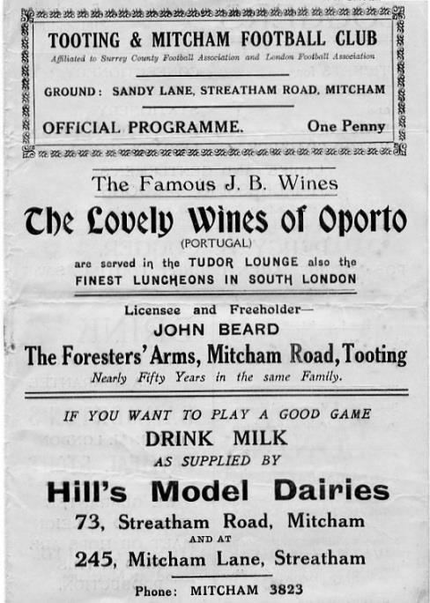
85 years ago today we visited Sandy Lane, the home of the recently merged Tooting & Mitcham United for our traditional Easter fixtures, winning 4-0. Leslie Marlow scored twice while J.Gillespie and Jimmy Jones got the others in this comfortable win as we would end up as runners-up in the London League behind our nemesis Park Royal, despite defeating them twice this year! (see programme left)

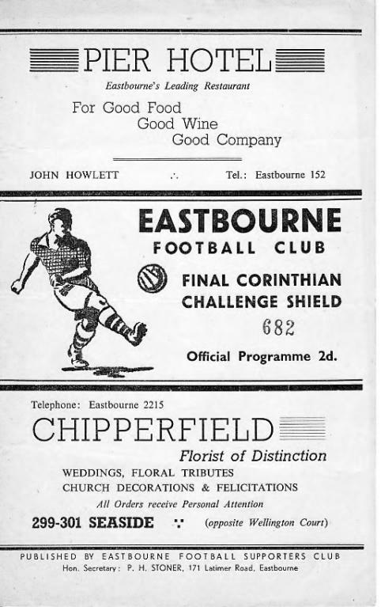
66 years ago today we visited the Saffrons for a Corinthian League Memorial Shield Final on the Easter Monday morning against Hounslow. 5,000 spectators were present to see Denis Ford give us a first half lead, only for two late goals to deny us the Shield. Hounslow completed the League and Cup double that season while we would have to wait eight more years to finally lift the Shield. (see programme below)

37 years ago today we defeated F.A. Trophy Finalists and local rivals Sutton United by three goals to two at West Street in a Surrey Senior Cup Semi-Final replay, going on to win the cup for the first time, six days later. Youngster David Hanks was the hero that day with two goals, while Tommy Tuite got the other as we recovered from trailing to defeat our neighbours in our first competitive meeting since 1957.

28 years ago today Adrian Hill was back in charge as his new young guns won 5-0 at Malden Vale with all the goals coming up the hill in the second half. Clive Hadingham scored twice, while another goal came from James Dack who would go on to play and manage at a high level.

10 years ago this week Egham Town visited Merland Rise for a League fixture and were winning 2-1 when the match had to be abandoned for an injury to a visiting player. The match was replayed seven days later where we secured a 2-2 draw with a late equaliser.

Centre page for results

Centre page for results

Buildbase F.A. Vase
Fifth Round – 3rd February
Wolverhampton SC | 3-4 | Leighton Town
Thatcham Town | 2-1 | Bromsgrove Sporting
Marske United | 2-0 | Bradford Town
Coleshill Town | 2-4+ | Bracknell Town
1874 Northwich | 1-0 | Chichester City
Stockton Town | 3-0 | Stourport Swifts
Windsor | 2-0 | Hamble Club
Melksham Town | 2-1 | Tring Athletic
Quarter-Finals – 24th February
Bracknell Town | 0-3 | Marske United
Melksham Town | 0-1 | Thatcham Town
Stockton Town | 2-0 | Windsor
Leighton Town | 0-1 | 1874 Northwich
Semi-Finals – 17th March & 24th March – two legs
Stockton Town | 2-0 – 1-2 | Marske United
Thatcham Town | 1-0 – 3-2 | 1874 Northwich

Combined Counties League Cup
Quarter-Finals
Godalming Town | 0-2 | Knaphill
Spelthorne Sports | 1-3 | Walton & Hersham
Sutton Common Rovers | 2-1 | Cobham
Worcester Park | 5-2 | Colliers Wood United
Semi-Finals
Worcester Park | 3-2 | Sutton Common Rovers
Walton & Hersham | 1-2 | Knaphill

Surrey Senior Cup
Second Round
Leatherhead | 2-0 | Kingstonian
Epsom & Ewell | 0-5 | Merstham
Farnham Town | 0-3 | Met Police
Westfield | 2-3 | Colliers Wood United
Spelthorne Sports | 0-4 | South Park
Sutton United | 7-1 | Molesey
Chipstead | 3-2 | Tooting & Mitcham United
Dorking Wanderers | 2-1 | Carshalton Athletic
Quarter-Finals
Met Police | 1-1 - (2-4p) | Leatherhead
Colliers Wood United | 0-6 | Dorking Wanderers
Sutton United | 1-2 | Merstham
Chipstead | 0-1 | South Park
Semi-Finals
Dorking Wanderers | 0-1 | Leatherhead
Merstham | 6-0 | South Park

Westfield F.C. – History
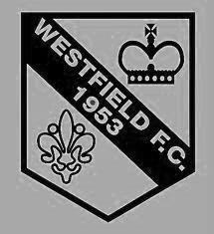
Westfield Football Club was formed in 1953 as Westfield Boys Club, playing in the Woking and District League and also running a youth team.

The 1950s

From the start the Club had success in the competitions it entered. Among the trophies won in the early years were the Surrey Youth Invitation Cup in 1953/54, the Surrey Junior Charity Cup in 1954/55 and 1955/56, the Surrey Junior Cup (at the first attempt) in 1955/56 and the Surrey Youth Cup in 1956/57.

Following several seasons in local league football, the Club made the break into Surrey Intermediate football using the present ground at Woking Park. Successes soon came and, after becoming League Champions and Cup winners on several occasions in the subsequent seasons, the Club decided to apply for senior status. The application was accepted in 1964 and after one season in the Parthenon League, Westfield met the necessary ground grading requirements and joined the Surrey Senior League.

The 1960s, 1970s, 1980s and 1990s

Westfield's future success in senior football sprang from their ability to attract the best local youngsters, and they were successful in winning the Surrey Youth Cup again in 1966/67 and 1969/70, and the Surrey Youth Shield in 1969/70 and 1970/71. This talent matured and there followed three tremendous seasons for the senior side, when they won the Surrey Senior League Cup in 1971/72, followed by the League and Cup double in 1972/73, and the League Championship again in 1973/74.

The Surrey Senior League reformed as the Combined Counties Football League in 1978, and Westfield FC became founder members and have retained membership to date. Success, however, has been more difficult to achieve and in recent times the closest the senior team has come to honours was in 1989/90, when they lost the final of the Combined Counties League Cup to Hartley Wintney in extra time.

2000-2003

In recent seasons with former Woking player, John Cassidy as manager, the senior side improved their league position, finishing sixth in season 2000/01. That season saw the Club enter the Carlsberg FA Vase for the first time, performing beyond expectations before losing in the Fourth Round to Ryman League Arlesey Town, on the way beating Wantage Town, Lewes and Bowers United.

Season 2002/03 saw Westfield enter the FA Cup for the first time, losing at home to Dorking in the Preliminary Round.

2003-2006

Following the end of the 2003/04 season/ Westfield lost both First and Reserve Team managers. John Cassidy moved to Frimley Green, and thereafter back to Farnham Town, and Graham Pope moved to Godalming & Guildford to manage their reserve team in the Suburban league. Westfield recruited Paul Donaghy from Guildford-based Merrow as first-team manager, and Dave Robson - long-time Westfield player - took over the reserves.

At the end of 2005/06 Westfield were relegated to the Ist Division, due to new ground-grading regulations after a very acrimonious conflict with the league. Numerous commitments from league

officials were reneged upon, and after months of appeals and meetings, Westfield had to accept their unwelcome fate.

After a mid-table Division 1 season and paftly because of the league-enforced relegation, Manager Paul Donaghy decided to resign as First Team manager to join Godalming and Reserve Team manager Dave Robson also quit. The team of ex-player Martin Powell, ex-Spurs stalwart David Howells and coach John Comer took over the running of the senior teams for the start of the 2007/08 season.

2007-2010

In the close season of 2007/08, following a highly credible 4th place finish, Martin resigned as manager due to personal circumstances; his departure signalled the exits of both David Howells and John Comer. In July 2008 the position of 1st Team Manager was filled by Steve Plunkett, the ex-Godalming Town Reserves boss, though he was replaced within 4 months by the returning Dave Robson, as the club attempted to rebuild following a mass exodus of players.

Dave Robson did a fine job stabilizing the club, but after an indifferent 2009/10 was replaced by joint managers, Craig Moore and John Comer.

Off the pitch there was good news, as building of the new facilities commenced in 2010/11 and it promised to be a good season as the management duo assembled the best squad since the 2008 season. However, despite some wonderful results, the team struggled to find consistency, and finished a disappointing 13th in the table.

2011-2015

During the summer of 2011, Craig Moore decided to step down to concentrate on playing, leaving John Comer as sole manager. He promoted Kevin Bailey from the reserves to be his assistant, and following Dave Kelly’s resignation as reserve team manager appointed David Robertson.

In May 2011 the old pitch was dug up and raised a metre, before being re-seeded and in June the old clubhouse was demolished. The club moved into the new facilities in August 2011 with a thrilling opening match in the FA Cup against Peacehaven & Telscombe, in which the Sussex side eventually ran out 6-3 winners, in front of a crowd of 190.

The following month a new record attendance for a league fixture at Woking Park was set when 325 witnessed the flxture against Guernsey.

The season saw another improvement on the pitch, where a position of 8th was achieved and the team reached a cup final for the first time in nearly 20 years. However they went down 4-2 to Warlingham on the day.

The following season the Club gained promotion in third place, and played Walton Casuals Reserves in the final of the Surrey Premier Cup, going down 2 goals to 1 in a close game.

In season 2013/14, with lohn Comer continuing as manager, the Club had their best league finish since 1981, ending in fourth place.

With John Comer's depature, Maftin Beard was appointed for the 2014-15 season. After a run of indifferent results, Maftin was replaced by Dan Snare, who improved the side to finish mid-table.

2016 to date

For the 2016-17 season, Tony Reid has been appointed manager, and enjoyed a stunning season, flnishing second in the League and winning the League Cup in May. We wish him and his management team well for another tremendous season.

Every Opponent A-Z
Over the years we have played many, many different opponents. Exactly how many is a difficult question, as it all depends on your definition. Are Camberley & Yorktown different to Camberley Town, or are Epsom Town different to Epsom F.C. or Epsom & Ewell F.C.?

In my analysis I have classed them as the same team, and will work through them all from A to Z. Some we have played many times, whilst others we have met maybe just once or twice. Enjoy!

Woodford Town: Played 9 - W4 D2 L3 – F22 A20 - PPG - 1.56 - Above Average

Snakes Lane does not sound like the sort of place that anyone would want to call home, but for Woodford Town they would give the world to be able to return to their base from 1937 to 1993.

Woodford Town were formed just before the war and were founder members of the Delphian League in 1951. Before that though they were members of the London League and we met them there for three seasons from 1946/47 to 1948/49. We made our first visit there on 25th January 1947, a week before the bad winter took hold; one that has only been beaten in terms of severity since by the infamous 1962/63 season. Jim Chennell and H.Wigham scored our goals in a 2-2 draw and exactly two months later we defeated them 4-2 at West Street in the return fixture with Don Ralph scoring twice.

Woodford Town’s main stand pictured in 1972 (courtesy – Bob Lilliman) It was unchanged in 1988

In 1947/48 the situation was a similar one as we recorded a home win and an away draw. The 2-0 home win came on 14th February 1948, just seven days after our 14-0 club record defeat at Chelmsford City Reserves so it was quite a good response! Our last league meetings came in the space of two weeks in January 1949 in rather similar circumstances. On New Year’s Day 1949 we trailed 2-0 at half time yet turned it around to win 4-3, yet on 15th January we led 2-1 at the half only to lose 3-2 at Snakes Lane.

We were battered 5-1 there in an Amateur Cup tie on 22nd September 1951 and although we won a Friendly challenge match in 1957 we made one final visit there on Wednesday 7th December 1988 for a London Senior Cup tie, by which time they were an established Southern League club and they edged us out 2-1 on my only visit to the ground.

It was a strange place by the time we visited, as their clubhouse was in fact a nightclub! It was open and in full swing and I recall not being able to hear a word as it was too loud! The ground itself was not an inspiring place, not least due to our failure to win there on our five visits. It was decaying

and there were rumours that they would have to leave shortly. The mater was worsened when the nightclub was burnt down in a fire and they left in 1993, never to return, folding around ten years later after a succession of ground shares, finally at Clapton’s Old Spotted Dog Ground.

Two clubs merged into one and took up the mantle of the old club, but they hit trouble and had to spend 2016/17 in abeyance before returning in the South Midlands League as Woodford Town (2017) and playing out of Brimsdown Rovers ground that had previously hosted Enfield Town in its formative years. The irony remains that the old Snakes Lane ground still exists as an open space to this day with a sporting covenant on it. Maybe one day….!

Woolwich Polytechnic: Played 7 - W3 D0 L4 - F16 A21 - PPG - 1.29 - Below Average

At the same time as we met Woodford Town, Woolwich Polytechnic were also members of the London League in the late forties. However, meetings with them go back a lot further; to Intermediate League level in fact, with League meetings occurring in the Southern Suburban League in 1923/24. We visited Kidbrooke Lane in Eltham Well Hall on 3rd November 1923 where we were extremely unfortunate to draw 1-1, but won 1-0 in the return at Horton Hospital on 29th December that same year.

We moved up to the Senior ranks following our title win that season and Woolwich Polytechnic followed soon after. We met for the first time at our new level on 15th October 1938, winning 5-4 in a wild London Senior Cup tie at West Street and then, like Woodford, spent three years as League rivals from 1946/47 to 1948/49, and failing to win on any of our visits there either! They completed a double over us in 1946/47 including a 4-1 win at West Street on 17th May 1947, following the harsh winter I referred to earlier. This would be the only time they would win at West Street though as the home side won all the remaining four League meetings.

We moved up to the Corinthian League in 1949, while they remained in the London League until they were relegated in 1956, returning to the top flight briefly for a season in 1963/64 at which point the League changed its name to the Greater London League, eventually merging with the Spartan League and then the South Midlands League which still exists to this day. Unfortunately, the Poly dropped from this level of football a long time ago and whilst the Polytechnic still exists, any sporting prowess is now restricted to its younger players.

Worcester Park: Held over to next issue

Worplesdon: Played 6 - W6 D0 L0 - F25 A7 - PPG - 3.00 - Perfect

Worplesdon were a Surrey Senior League team playing out of the Worplesdon Memorial Ground, then as now, just off the Worplesdon Road A322 in Perry Hill. They joined the League when it expanded in 1968/69 but in three years there they never finished outside the bottom two and when the expansion was shelved in 1971 and the league reverted to one division they dropped out again. However, they returned in 1973 at the higher level and this is where they met us.

Of course, we were extremely good back then and won all four League meetings including a League Cup tie in 1975 with all wins being by at least two goals and on one occasion, 6-2 in December 1973 with Micky Dunne scoring four times. We also won 5-2 when paired together for our final meeting in the Surrey Senior Cup on 25th September 1976 and by the end of that season with all four years spent in the bottom four, the Surrey Senior League sent them back to Intermediate football.

However, after a season out they reappeared as Guildford & Worplesdon in 1978/79 with Guildford City and Guildford & Dorking having failed as clubs, and they won the first season of the newly named Combined Counties League in 1979/80, remaining until 1983/84 whereupon they resigned and have remained in the Surrey Intermediate League ever since. Now newly named as Worplesdon Phoenix Tigers following two mergers they still survive at the same venue.

Player Sponsorship
Here is the latest list for 2017/18, with new photos showing all of our players and Management that are now available for sponsorship.

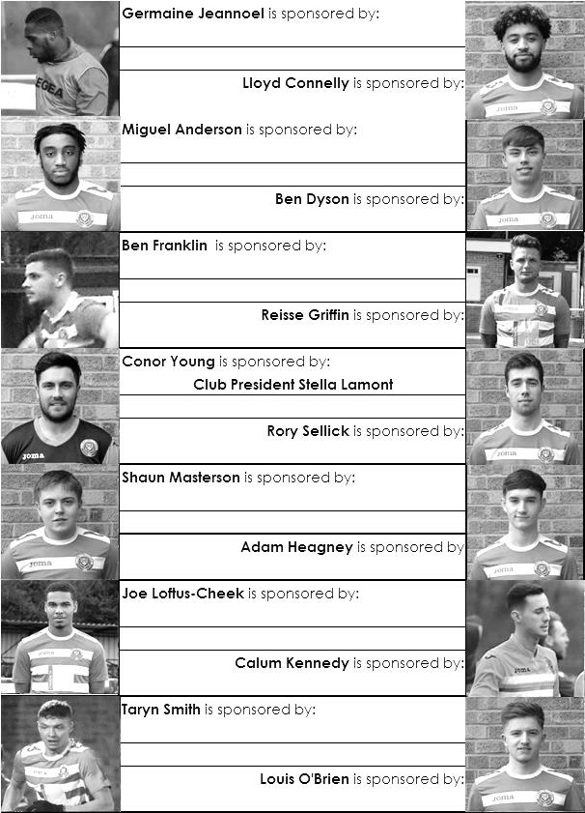

Sponsorship costs just £40 and it is easy to do. Just select a player who has not been previously sponsored and let a Committee Member know. Don’t delay, sponsor today!

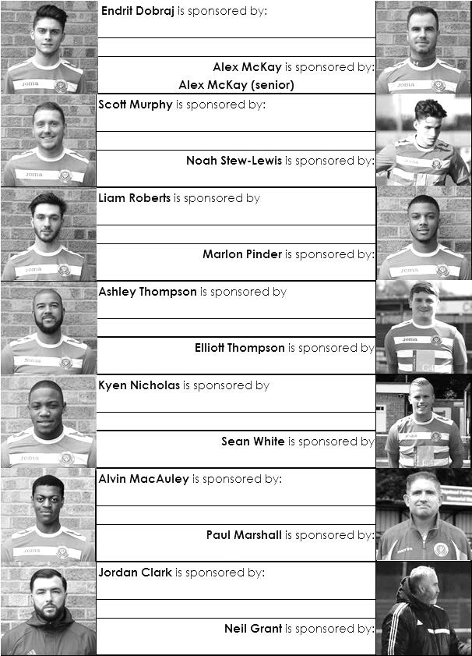

Combined Counties League Premier Division
Opponents All-time Records
inc Saturday  7th April | P | W | D | L | F | A | PPG | GD | Best  Win | Worst  Loss
Horley Town | 32 | 21 | 5 | 6 | 71 | 37 | 2.13 | +34 | 6-0 | 1-3
Sutton Common Rovers* | 15 | 9 | 3 | 3 | 30 | 21 | 2.00 | +9 | 4-0 | 0-5
Spelthorne Sports* | 9 | 5 | 3 | 1 | 16 | 11 | 2.00 | +5 | 6-2 | 1-5
Godalming Town | 3 | 2 | 0 | 1 | 4 | 5 | 2.00 | -1 | 2-1 | 0-3
Banstead Athletic | 39 | 23 | 8 | 8 | 64 | 40 | 1.97 | +24 | 5-0 | 0-4
Abbey Rangers | 6 | 3 | 2 | 1 | 12 | 5 | 1.83 | +7 | 7-1 | 2-3
Farnham Town | 17 | 9 | 4 | 4 | 30 | 25 | 1.82 | +5 | 3-0 | 1-4
Westfield | 22 | 12 | 3 | 7 | 43 | 41 | 1.77 | +2 | 6-1 | 0-5
Bedfont Sports | 13 | 7 | 2 | 4 | 23 | 23 | 1.77 | 0 | 5-1 | 0-7
Colliers Wood United | 25 | 14 | 2 | 9 | 47 | 40 | 1.76 | +7 | 4-0 | 0-5
Guildford City | 20 | 11 | 1 | 8 | 39 | 29 | 1.70 | +10 | 5-1 | 1-5
Knaphill | 10 | 5 | 2 | 3 | 20 | 16 | 1.70 | +4 | 4-0 | 2-6
Hanworth Villa | 19 | 9 | 5 | 5 | 42 | 30 | 1.68 | +12 | 5-0 | 1-4
Walton & Hersham | 53 | 25 | 11 | 17 | 105 | 101 | 1.62 | +4 | 8-0 | 1-9
Camberley Town** | 92 | 38 | 24 | 29 | 159 | 126 | 1.50 | +33 | 9-1 | 0-4
Redhill | 35 | 14 | 2 | 19 | 63 | 77 | 1.26 | -14 | 7-2 | 2-8
Chertsey Town | 51 | 19 | 5 | 27 | 77 | 95 | 1.22 | -18 | 3-0 | 0-7
North Greenford United | 13 | 4 | 2 | 7 | 19 | 24 | 1.08 | -5 | 3-0 | 1-4
AFC Hayes | 11 | 2 | 3 | 6 | 18 | 20 | 0.82 | -2 | 7-0 | 0-3
CB Hounslow United | 4 | 1 | 0 | 3 | 6 | 11 | 0.75 | -5 | 2-0 | 1-5
Balham | 2 | 0 | 0 | 2 | 0 | 6 | 0.00 | -4 | x | 0-4
* includes one loss on penalties v Spelthorne and one win on penalties v Sutton Common Rovers
** includes one abandoned match v Camberley

Match and Ball Sponsorships – 2017/18
Opponent | Date | Match Sponsor | Ball Sponsor
Banstead Athletic (FAC) | 06/08/17 | Club President - Stella Lamont
Chertsey Town | 15/08/17 | EEFC Management Committee
Redhill | 02/09/17 | Building Shop Ltd
Spelthorne Sports | 09/09/17 | In memory of Betty Dyke
Horley Town | 12/09/17 | Alex McKay (Senior)
Hanworth Villa | 23/09/17 | Jack Jarman
North Greenford United | 28/10/17 | Marvin and Kathy Hough
Farnham Town | 14/11/17 | In memory of Dave and Lizzie Marshall
Godalming Town | 21/11/17 | Building Shop Ltd
Guildford City | 02/12/17 | John Bonner
Walton & Hersham | 30/12/17 | Jeff and Arnold Pye
Merstham (SSC) | 16/01/18 | Paul Merritt
Abbey Rangers | 23/01/18 | Pete Beddoe’s grandchildren  George, Joseph, Ezara & Inaya
Sutton Common Rovers | 03/02/18 | David Ellins
Knaphill | 24/02/18 | Jack Jarman
Camberley Town | 10/03/18 | Pete Lumm
Balham | 13/03/18
Bedfont Sports | 24/03/18 | EEFC Management Committee
Colliers Wood United | 30/03/18
Banstead Athletic | 02/04/18 | Nathan Lambert – 10 years old today!
Westfield | 14/04/18
CB Hounslow United | 17/04/18
AFC Hayes | 28/04/18 | Club President - Stella Lamont
Match sponsorship costs just £60.00!

Sponsorship includes:

Admission, programmes and hospitality for three people.

A full page advert in the programme and mascot for the day (if required).

Also, you get to choose the player of the match, who will receive a prize

If you are interested, just speak to a Committee Member,
or drop me an email at: richard.c.lambert@gmail.com

CCL Premier Division Club Directory 2017/18
ABBEY RANGERS Telephone: 01932-422962 - Colours: Black & White Stripes/Black/Black
Ground: Addlestone Moor, Addlestone. KT15 2QH

A.F.C. HAYES Telephone: 0208-845-0110 - Colours: Blue and White Stripes/Blue/Blue
Ground: Farm Park, Kingshill Avenue, Hayes. UB4 8DD

BALHAM Telephone: 0208-942 8062 - Colours: White & Black/Black/Black

Ground: Colliers Wood United FC - Wibbandune, Robin Hood Way, Wimbledon. SW20 0AA -

BANSTEAD ATHLETIC Telephone: 01737-350982 - Colours: Amber &Black/Black/Black
Ground: Banstead Athletic, Merland Rise, Tadworth. KT20 5JG

BEDFONT SPORTS Telephone: 0208-831-9067 - Colours: Red & Black Hoops/Black/Red & Black
Ground: Bedfont Sports Club, Hatton Road, Bedfont. TW14 8JA

CAMBERLEY TOWN Telephone: 01276-65392 Colours: Red & White Stripes/Blue/Red
Ground: Krooner Park, Wilton Road, Camberley. GU15 2QW

CB HOUNSLOW UNITED Telephone: 0208-577 -9712 Colours: Green/Black/Green
Ground: CB Hounslow Sports Ground, Green Lane, Hounslow TW4 6DH

CHERTSEY TOWN Telephone: 01932-561774 - Colours: Royal Blue & White Stripes/ Blue/ Blue
Ground: Alwyns Lane, Chertsey. KT16 9DW

COLLIERS WOOD UNITED Telephone: 0208-942 8062 - Colours: Royal Blue/Black/Black
Ground: Wibbandune, Robin Hood Way, Wimbledon. SW20 0AA

EPSOM & EWELL Telephone: 01737-553250 - Colours: Royal Blue & White Hoops/Royal Blue/Royal Blue - Ground: Chipstead FC, High Road, Chipstead. CR5 3SF

FARNHAM TOWN Telephone: 01252-715305 - Colours: - Claret & Sky Blue /White/ Claret & Blue
Ground: Memorial Ground, Babbs Mead, West Street, Farnham. GU9 7DY

GODALMING TOWN Telephone: 01483-417520 - Colours: Yellow/Green/Yellow
Ground: Wey Court, Meadrow, Godalming. GU7 3JE

GUILDFORD CITY Telephone: 01483-443322 - Colours: Red & White Stripes/Black/Black
Ground: The Spectrum, Parkway, Guildford, Surrey. GU1 1UP

HANWORTH VILLA Telephone: 0208-831-9391 - Colours: Red & White Stripes/Black/Black
Ground: Rectory Meadows, Park Road, off Hounslow Road, Hanworth. TW13 6PN

HORLEY TOWN Telephone: 01293-822000 - Colours: Claret & Sky Blue/Claret/Claret
Ground: The New Defence, Anderson Way, Court Lodge Road, Horley. RH6 8SP

KNAPHILL Telephone: 01483-475150 - Colours: Red/Black/Red & Black
Ground: Brookwood Country Park, Redding Way, Lower Guildford Road, Knaphill. GU21 2AY

NORTH GREENFORD UNITED Telephone: 0208 422 8923 - Colours: Royal Blue & White/Royal Blue/Royal Blue - Ground: Berkeley Fields, Berkeley Avenue, Greenford, Middx UB6 0NX

REDHILL Telephone: 01737-762129 - Colours: Red and White Stripes/Red/Red
Ground: Kiln Brow, Three Arch Road, Redhill. RH1 5AG

SPELTHORNE SPORTS Telephone: 01932-961055 - Colours: Navy & Sky Blue/ Blue/ Blue
Ground: Spelthorne Sports Club, 296 Staines Road, Ashford Common, Ashford. TW15 1RY

SUTTON COMMON ROVERS Telephone: 0208-644-4440 - Colours: Yellow/ Yellow / Yellow
Ground: Sutton United FC, Gander Green Lane, Sutton. SM1 2EY

WALTON & HERSHAM Telephone: 01932-245263 - Colours: Red & White Trim/Red/Red
Ground: Stompond Lane, Walton on Thames. KT12 1HF

WESTFIELD Telephone: 01483-771106 - Colours: Yellow/Black/Black
Ground: Woking Park, Kingfield Road, Woking. GU22 9BA

Salts Super Six Predictor
The Salts Super Six Predictor jackpot was recently claimed and is now at £151 for today’s match. The tickets are on sale to the left of the gate and the matches on the ticket are to be played today!

The competition is easy to play! To win, you simply need to predict the results of six matches correctly from the three options, fill in the form and make sure it is back with our seller before the deadline on the ticket. The latest fixtures are shown below.

If you are a club regular, you just need to place your name on the sheet, although if you aren’t, then we’ll need a contact number from you too. We will announce any winners on the website within three working days, so don’t worry, we won’t miss you!

Please note that if there is more than one winner, the prize pot would be shared between the winners. All you need to do now is have a go, as many times as you like!

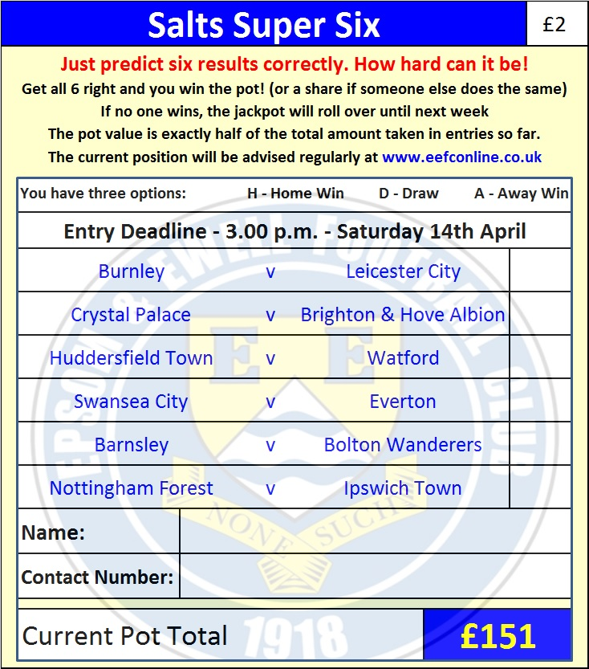

Good luck!

Combined Counties League – Premier Division
Saturday, 14th April 2018 - Kick-off 3.00 p.m.
Epsom and Ewell  (Royal Blue & White hoops) | V |  | Westfield  (Yellow and Black)
Squad | NUMBERS |  | Squad
Conor Young |  |  | Gary Ross
Endrit Dobraj |  |  | Matt Steer
Shaun Masterson |  |  | Joshua Cover
Adam Heagney |  |  | Leavan Sullivan
© Alex McKay |  |  | Adam Bellmaine
Ashley Thompson |  |  | Kyle Bailey
Marlon Pinder |  |  | Shaun Elliott ©
Scott Murphy |  |  | James Mariner
Kyen Nicholas |  |  | TSharne Gallimore
Elliott Thompson |  |  | Karle Carder-Andrews
Ben Dyson |  |  | Dale Burnham
Lloyd Connelly |  |  | Max Blackmore
Liam Roberts |  |  | Aaron Watson
Miguel Anderson |  |  | Jason Dwumfou
Ben Franklin |  |  | Bobby Dormer
Reisse Griffin |  |  | Andy Crossley
Stuart Russell |  |  | Jamil Okai
Jordan Clark |  |  | Louie Downey
Alvin MacAuley |  |  | Pat Kirby
Rory Sellick
Germaine Jeannoel
Joshua Caulcrick
Neil Grant | MANAGER |  | Tony Reid
Alex McKay | ASSISTANT |  | Lee Morris
 | COACH / PHYSIO |  | Louis Carder-Walcott / Avneet Jheeta
REFEREE: L.Pinto Nunes
ASSISTANTS: P.Jones, K.Corrick

OUR NEXT VISITORS TO HIGH ROAD
CB Hounslow United
Cherry Red Combined Counties League – Premier Division
Tuesday 17th April 2018 – 7.45 p.m.

